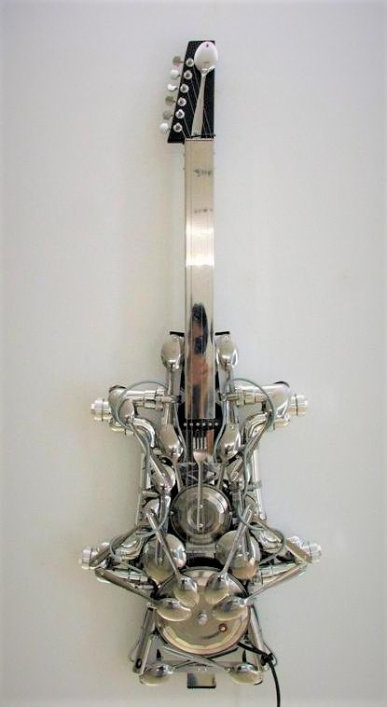

*Lirio Salvador*

“Sandata Ni Adan”.

Mixed media sculpture - instrument.

45½” X 17”

“Sandata Ni Adan” is Tagalog for “Adam’s Weapon”